Development and Characterization of a Paper-Based Graphite Sensor Using NaCl Electrolyte

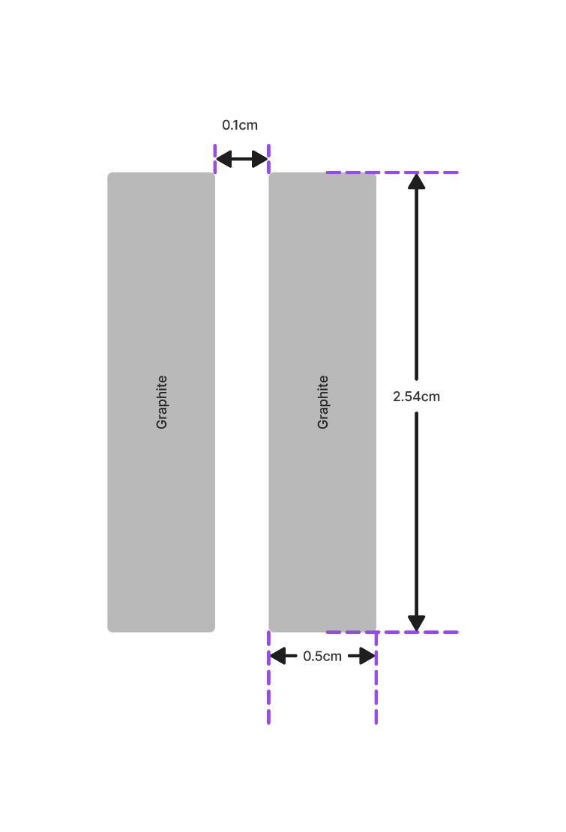
1. Sensor Fabrication
Pencil Graphite-Based Sensor
- Substrate: Grade 1 filter paper (hydrophilic)
- Active area:
  - Width = 0.4 cm
  - Height = 2.54 cm
- Electrode gap: 0.1 cm
- Conductive material: Graphite (manually deposited)
Electrical properties
The resistance of the graphite sensor follows:
$$R = ρ\frac{L}{A}$$
where,
- R = resistance
- $ρ$ = resistivity of graphite network
- L = effective length of the graphite track
- A = effective cross-sectional area
Observations:
- Resistance is directly proportional to sensor length
- Resistance is inversely proportional to the amount (weight) of graphite deposited
- Initial dry resistance range: 6 kΩ – 22.3 kΩ
The paper substrate absorbs the electrolyte, enabling ionic–electronic mixed conduction through the graphite network.

Graphite INK-Based Sensor
- Substrate: Grade 1 filter paper (hydrophilic)
- Active area:
  - Width = 0.4 cm
  - Height = 2.54 cm
- Electrode gap: 0.1 cm
- Conductive material: Graphite INK (manually deposited)
Electrical properties
The resistance of the graphite sensor follows:
$$R = ρ\frac{L}{A}$$
where,
- R = resistance
- $ρ$ = resistivity of graphite network
- L = effective length of the graphite track
- A = effective cross-sectional area
Observations:
- Resistance is directly proportional to sensor length
- Resistance is inversely proportional to the amount (weight) of graphite deposited
- Initial dry resistance range: 50Ω – 1.7 kΩ
The paper substrate absorbs the electrolyte, enabling ionic–electronic mixed conduction through the graphite network.
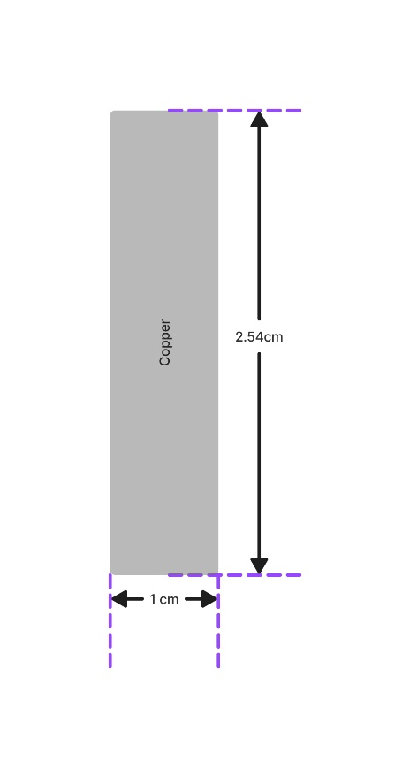
Pencil Graphite-Based single Probe Sensor
- Substrate: Grade 1 filter paper (hydrophilic)
- Active area:
  - Width = 1 cm
  - Height = 2.54 cm
- Conductive material: Pencil Graphite (manually deposited)
Electrical properties
The resistance of the graphite sensor follows:
$$R = ρ\frac{L}{A}$$
where,
- R = resistance
- $ρ$ = resistivity of graphite network
- L = effective length of the graphite track
- A = effective cross-sectional area
Observations:
- Resistance is directly proportional to sensor length
- Resistance is inversely proportional to the amount (weight) of graphite deposited
- Initial dry resistance range: 2.6 kΩ – 14.8 kΩ
The paper substrate absorbs the electrolyte, enabling ionic–electronic mixed conduction through the graphite network.

Copper-Based Sensor (Reference Probe)
Electrode material: Copper plates
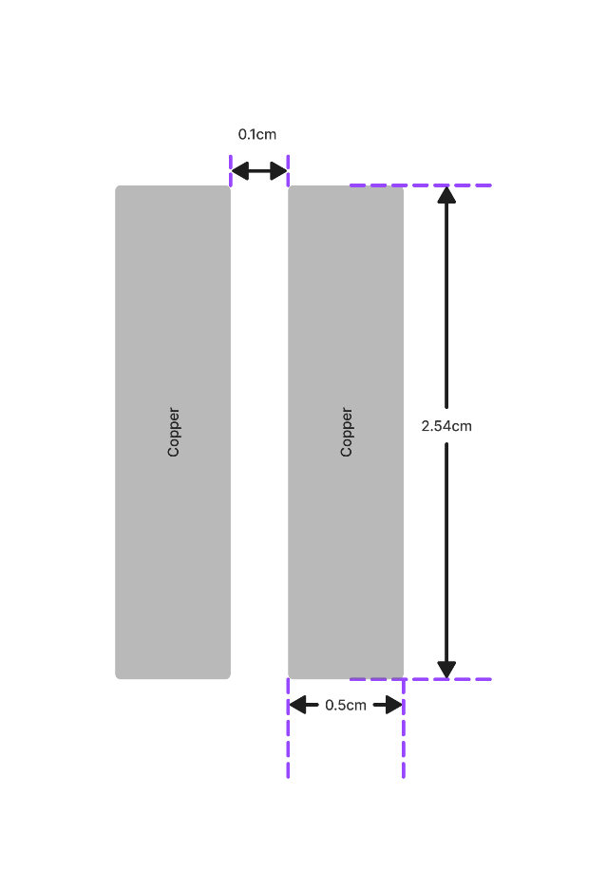
Dimensions: Identical to graphite sensor (0.5 × 2.54 cm)
- Substrate: Hydrophobic (does not absorb water)
- Initial resistance: Negligible (≈ 0 Ω)
This probe serves as a reference conductivity sensor, where conduction is dominated purely by the electrolyte.

2. Experimental Setup
Electrical Configuration
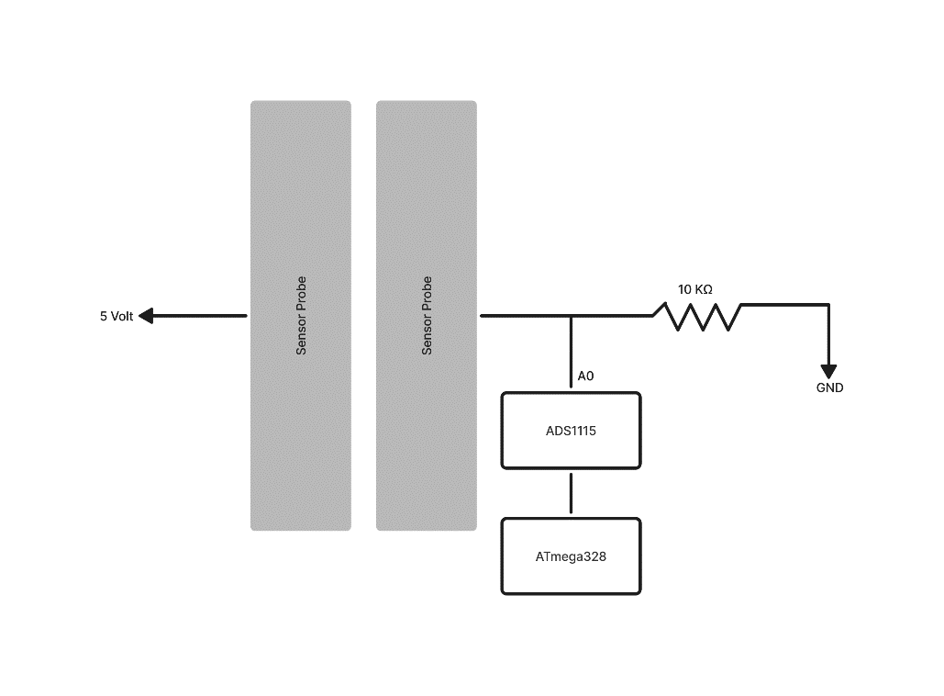
- Excitation voltage: 5 V DC
- Measurement circuit: Voltage divider
$$V_{out}= V_{in}×\frac{R_{fixed}}{R_{sensor}+R_{fixed} }$$
Where:
- $R_{fixed}= 10kΩ$
- $R_{sensor}$ varies with NaCl concentration

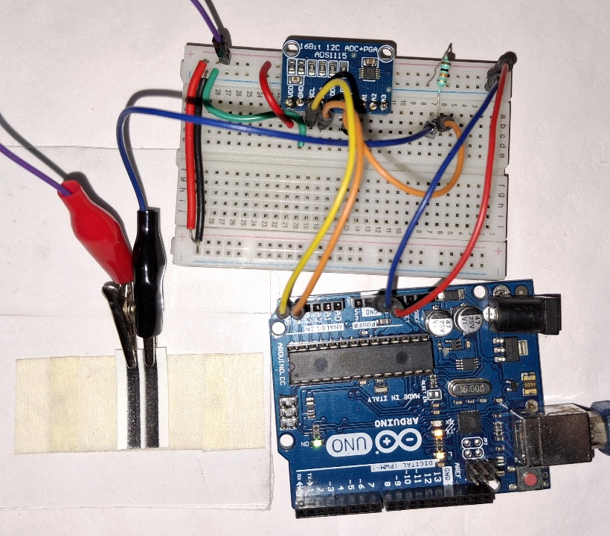
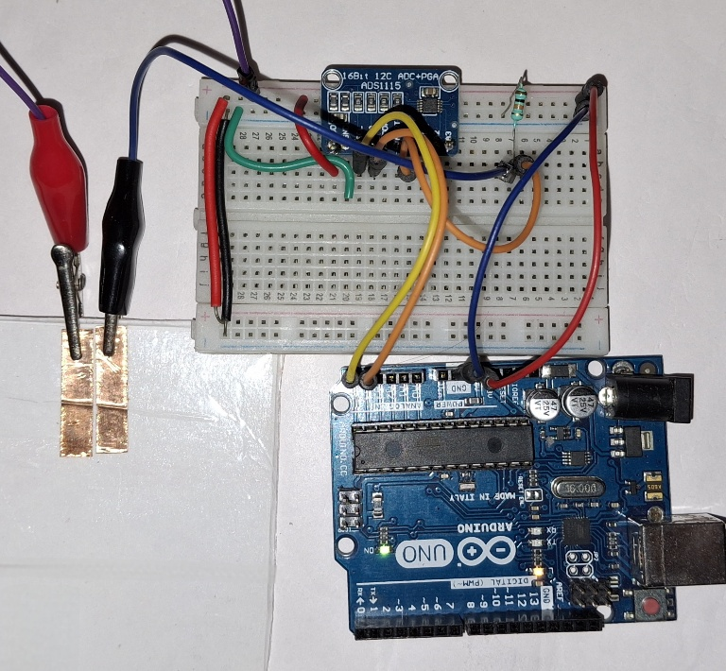
The output voltage is proportional to the effective conductivity of the sensor–electrolyte system.
Copper Sensor Setup Graphite Sensor Setup

Data Acquisition Hardware
- ADC: ADS1115 (16-bit)
- Gain setting:
- ads.setGain(GAIN_TWOTHIRDS);
  - Input range: ±6.144 V
  - Resolution: $1LSB = 0.1875mV$
- Controller: Arduino UNO (ATmega328)
ADC counts are converted to voltage as:
$$V = ADC_{count}×0.1875 mV$$

3. Data Collection Protocol
- Base solvent: 20 ml distilled water
- Solute: 99.9% pure NaCl
- Concentration range:
  - DRY_RUN (no solution)
  - 0 gm to 11 gm NaCl in 20 ml water.
- Procedure:
  - Sensor exposed to solution.
  - Continuous ADC data recorded.
  - Same protocol used for graphite and copper sensors.
Raw Data Plotting

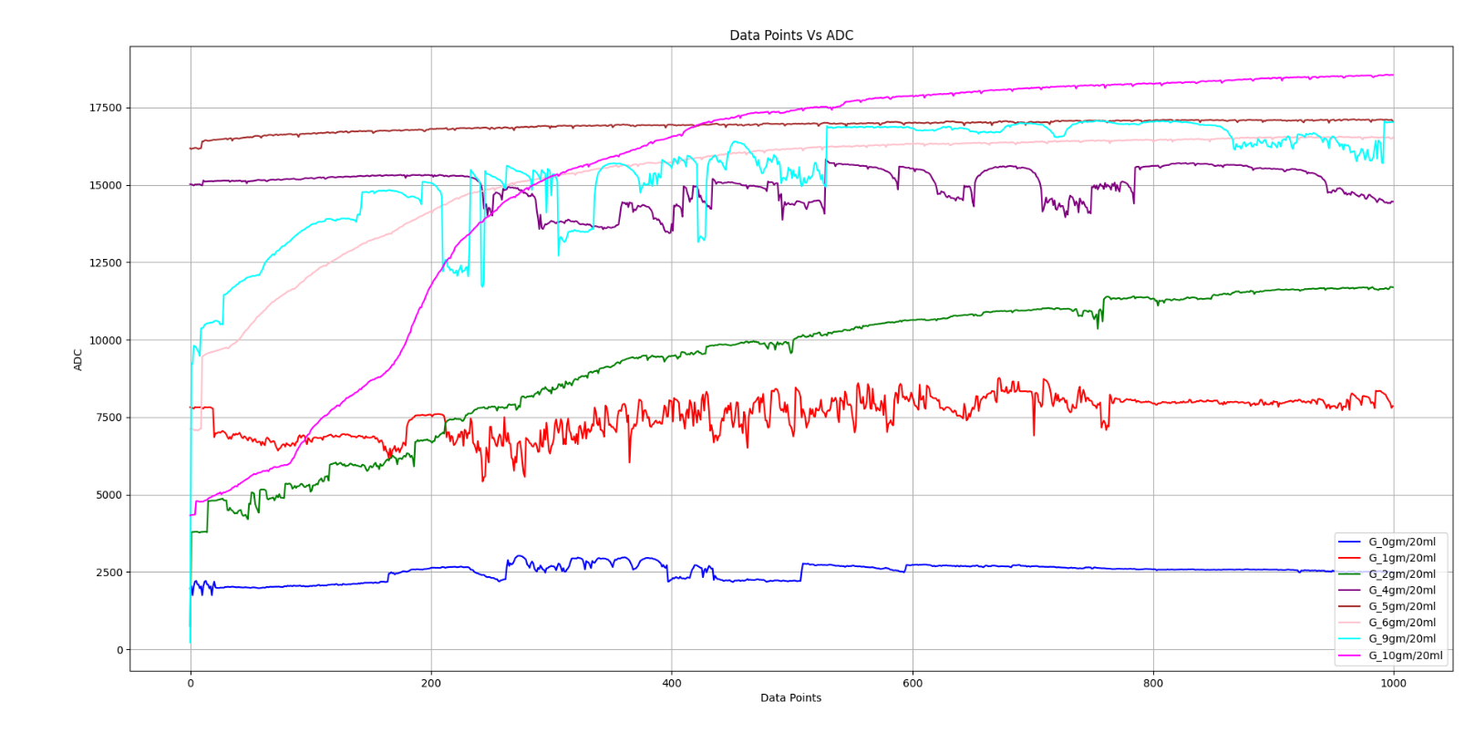
Data From Graphite sensor
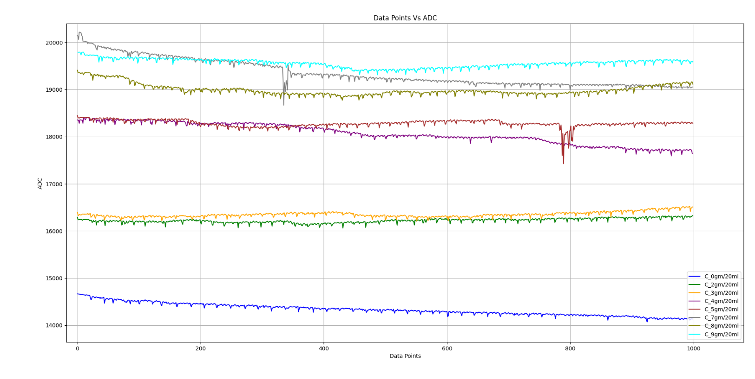
Data From Copper Sensor

4. Data Screening and Processing
Noise Reduction: Moving Average
A moving average filter is applied:
$$y_{smooth\left[n\right]}= \frac{1}{W}\sum_{K=-\frac{W}{2}}^{\frac{W}{2}}{y\left[n+k\right]}$$
- Window size: 1000 samples
- Purpose:
  - Suppress high-frequency noise
  - Remove transient spikes
  - Extract steady-state response
4.2 Feature Extraction (Per Concentration)
From the smoothed signal, the following parameters are computed:
- Minimum value:
$$y_{min}=\min\left(y_{smooth}\right)$$
- Maximum value:
$$y_{max}=\max\left(y_{smooth}\right)$$
- Mean value:
$$μ=\frac{1}{N}∑y_{smooth}$$
- Standard deviation:
$$σ= \sqrt{\left\{\frac{1}{N}∑{\left(y_{smooth}- μ\right)}^{2}\right\}}$$
- Range:
$$Range = y_{\max{-}y_{min}}$$
his reduces large time-series data into physically meaningful descriptors.
Min–Max Envelope Analysis
For each concentration:
- Min and max values form a response envelope
The average envelope is defined as:
$$y_{avg}=\frac{y_{\min{+}y_{max}}}{2}$$
This represents the effective sensor response while preserving variability.
Linearity Evaluation
Linear regression:
$$y = mx + c$$
Coefficient of determination:
$$R^{2}= 1 -\frac{∑{\left(y - y_{fit}\right)}^{2}}{∑{\left(y - \overline{y}\right)}^{2}}$$
Computed separately for:
- Min curve
- Max curve
- Average curve
This quantitatively evaluates concentration–ADC linearity.
5. Graphs After Screening
Pencil Graphite Based 2 probe sensor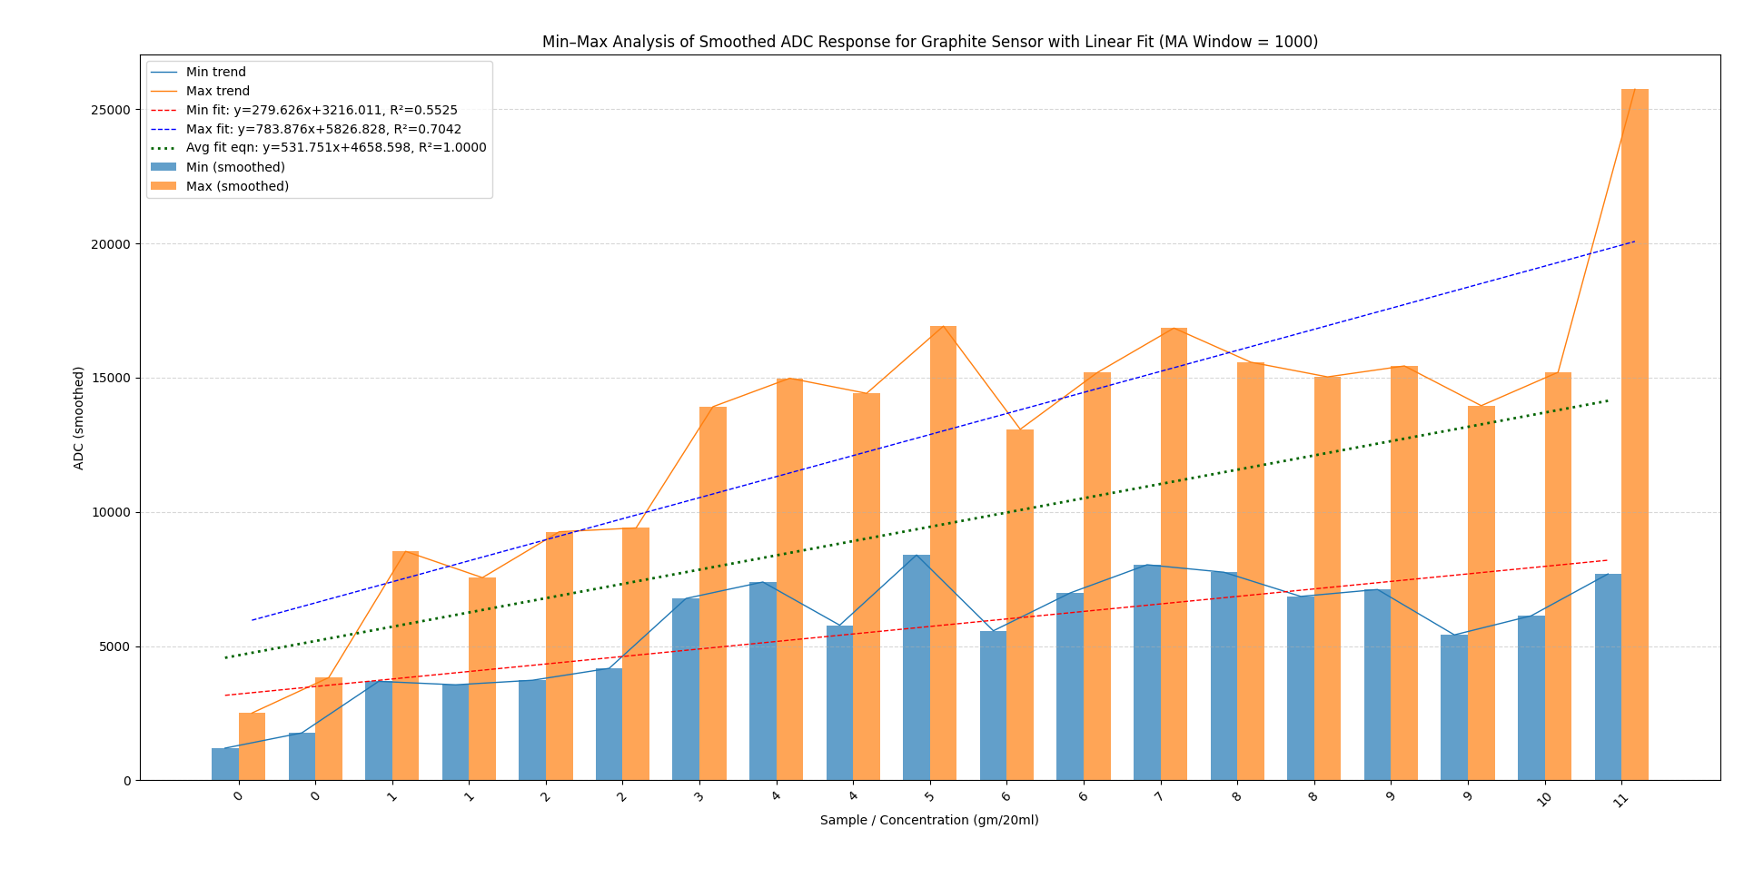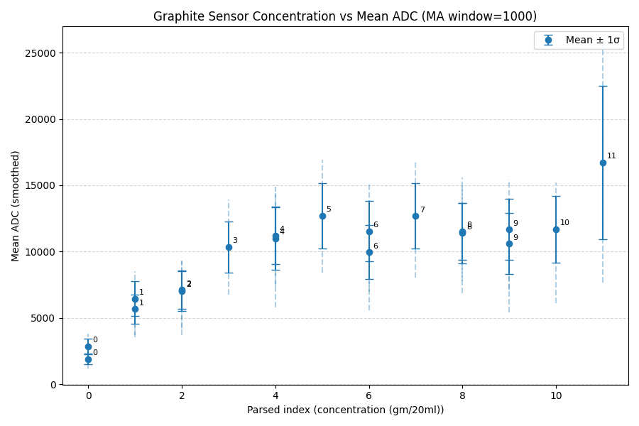
Graphine INK Based 2 probe sensor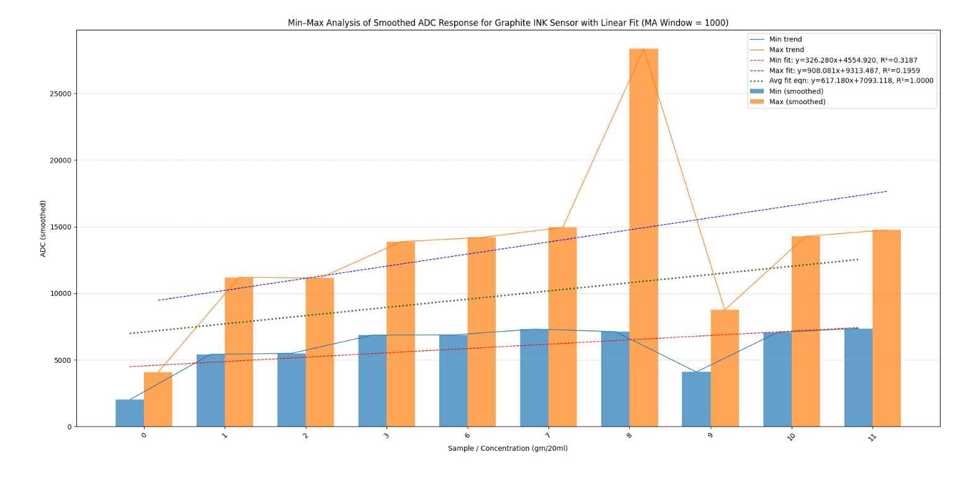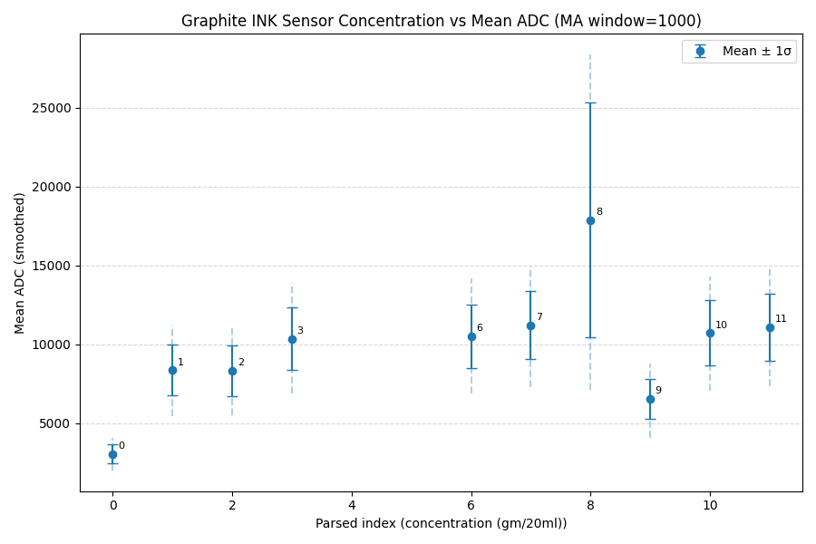
Pencil Graphite Based single probe sensor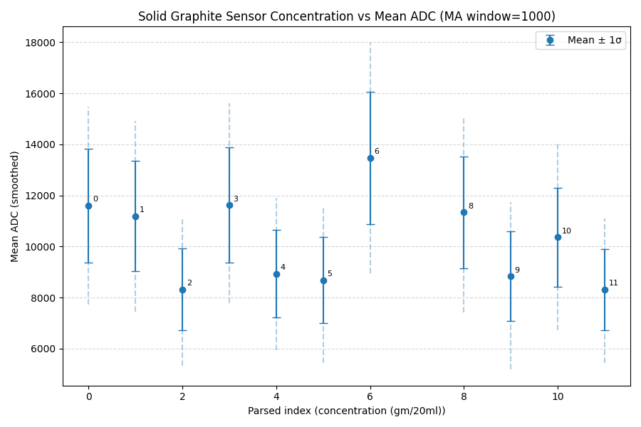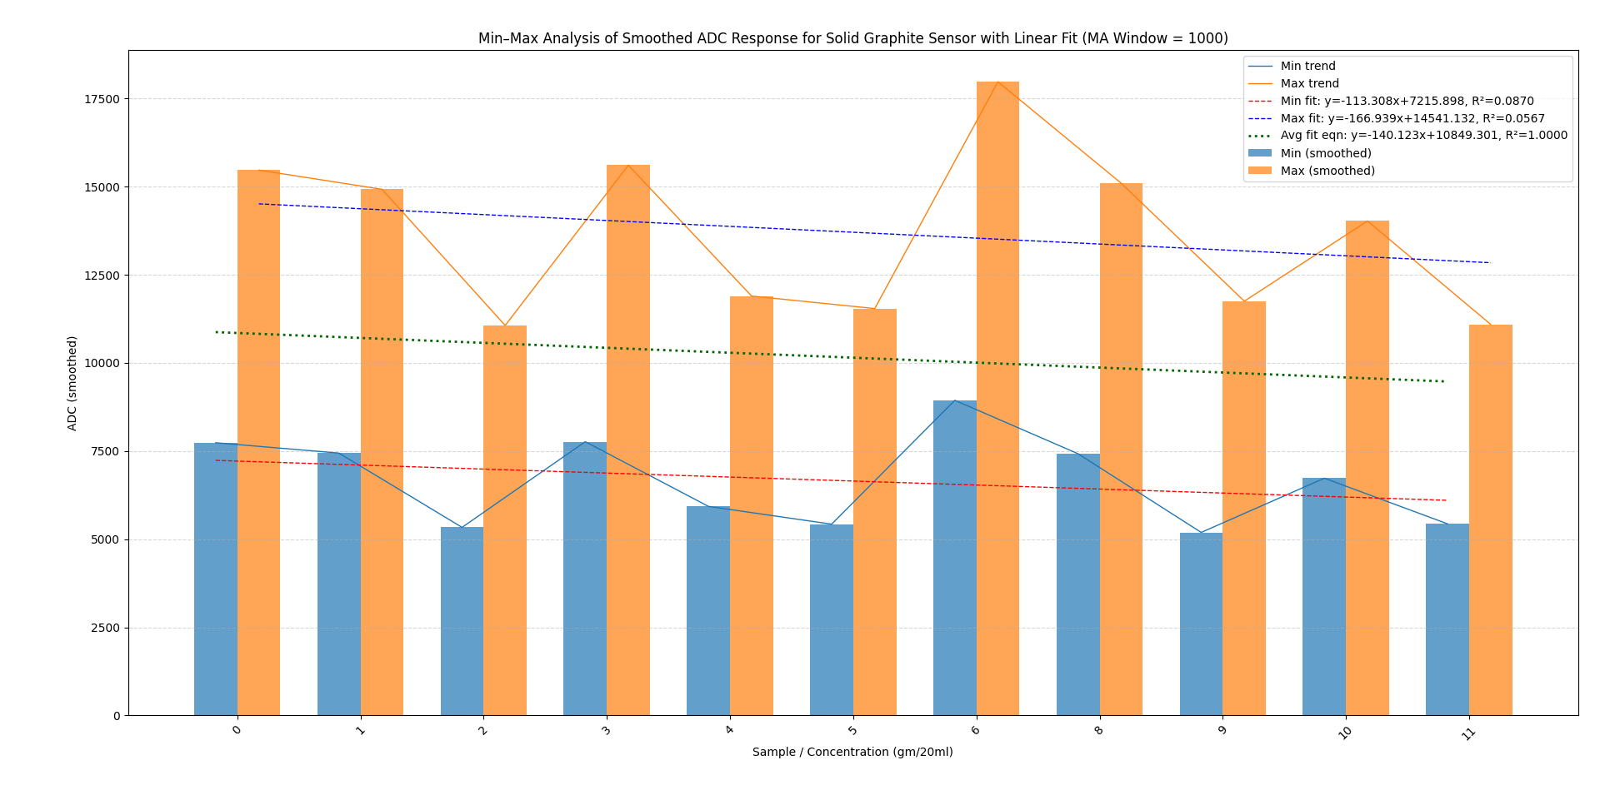
Copper based 2 probe sensor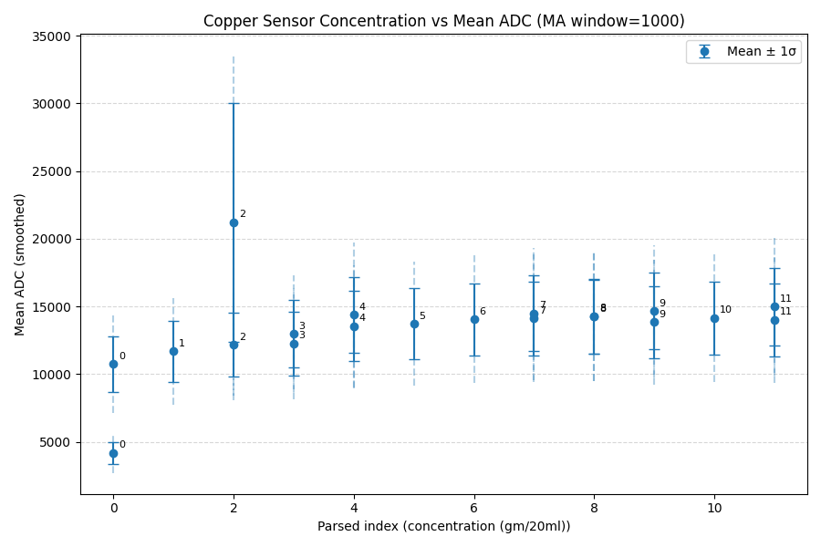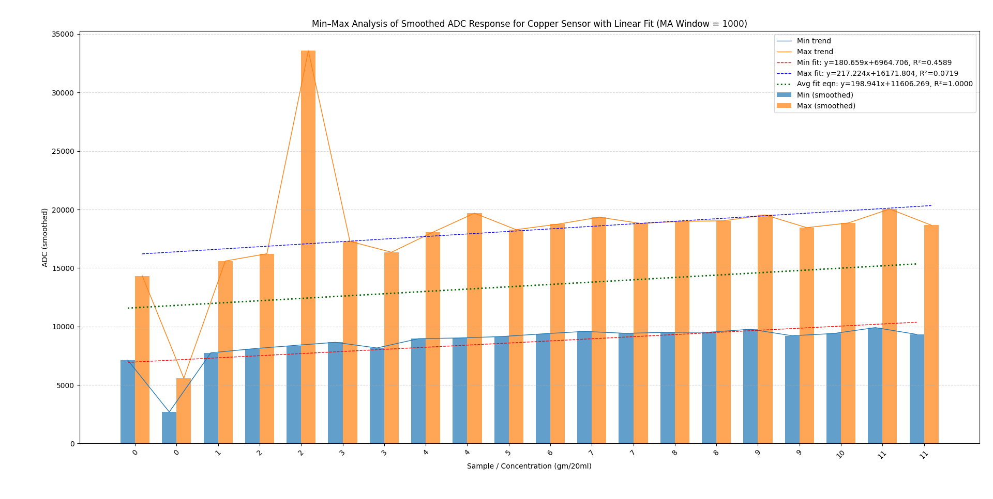

6. Key Findings
- Monotonic response:
ADC values increase consistently with NaCl concentration for both sensors.
- Copper sensor:
  - Higher linearity
  - Narrow response envelope
  - Stable and repeatable behavior
- Graphite-paper sensor:
  - Wider envelope due to material and substrate effects
  - Clear linear trend in averaged response
  - Functional as a low-cost sensing element
- Data processing pipeline successfully:
  - Removes noise
  - Preserves physical trends
  - Enables quantitative comparison

GitHub Link:
https://github.com/RaunakR16/Paper_Sensor/tree/main

